**Use Cases**

The use cases describe common scenarios of user interactions with the system, explaining how various functional requirements are applied in specific situations.   
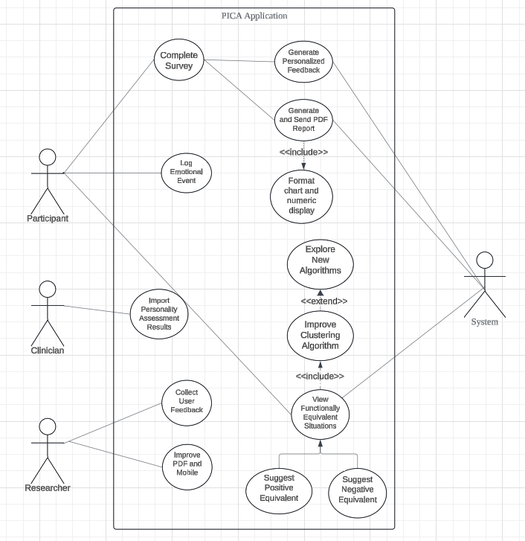

Figure l: Use case diagram

The description of each use case is given below.

**Use Case 1: Complete Survey**

| **Use Case** | Complete Survey |
| --- | --- |
| **Actors** | Participant |
| **Pre-condition** | Participant logged in and started the Qualtrics survey |
| **Post-condition** | The participant completed all survey questions and the system received the complete survey results. |
| **Main Flow** | - Participant opens the Qualtrics survey.  - Participant answers all questions and submits the survey.  - The system confirms the survey is complete and ready to generate feedback. |
| **Alternative Flow** | -If a participant drops out of the survey midway, the system saves the current progress and allows the participant to continue later. |
| **Related Requirements** | FR1:Results PDF  FR2:Automatic PDF Sending  FR3:Data Collection |

**Use Case 2: Generate Personalized Feedback**

| **Use Case** | Generate Personalized Feedback |
| --- | --- |
| **Actors** | System |
| **Pre-condition** | The survey was completed and the system received the participant's survey results. |
| **Post-condition** | Personalized assessment feedback was generated, including preliminary feedback and detailed feedback. |
| **Main Flow** | -The system receives and analyzes survey data from participants.  -The system generates preliminary feedback, including personality assessment results.  -The system generates detailed feedback, providing specific treatment strategies.  . |
| **Alternative Flow** | -If the data is incomplete, the system will generate feedback containing only basic information. |
| **Related Requirements** | FR1:Results PDF  FR5:PICA Based Questions  FR6:Clustering Algorithm  FR7:Data Collection |

**Use Case 3: Generate and Send PDF Report**

| **Use Case** | Generate and Send PDF Report |
| --- | --- |
| **Actors** | System |
| **Pre-condition** | Personalized feedback generated. |
| **Post-condition** | PDF reports were generated and emailed to participants and clinicians. |
| **Main Flow** | -The system generates a personalized PDF report based on the feedback, including charts and treatment recommendations.  -The system automatically sends the PDF report to the email address provided by the participant.  -The system confirms that the report was successfully sent.  . |
| **Alternative Flow** | -If the email fails to be sent, the system will record the failure information and try again. |
| **Related Requirements** | FR1:Results PDF  FR4:PICA Assessment Results  FR7:Data Collection |

**Use Case 4: Log Emotional Event**

| **Use Case** | Log Emotional Event |
| --- | --- |
| **Actors** | Participant |
| **Pre-condition** | Participants were logged into a mobile phone self-monitoring application. |
| **Post-condition** | Emotional events and related information have been saved to the database |
| **Main Flow** | -The participant opens the mobile app and chooses to record an emotional event.  -The participant enters the type of emotion, thoughts, feelings, and behavior information.  -The system saves the record and confirms that it was saved successfully.  . |
| **Alternative Flow** | -If the device is offline, the system will automatically sync the data when the connection is restored. |
| **Related Requirements** | FR5:PICA Based Questions  FR6:Clustering Algorithm FR7:Data Collection |

**Use Case 5: View Functionally Equivalent Situations**

| **Use Case** | View Functionally Equivalent Situations |
| --- | --- |
| **Actors** | Participant, System |
| **Pre-condition** | View Functionally Equivalent Situations |
| **Post-condition** | The system provides participants with functionally equivalent situational suggestions based on the recorded data. |
| **Main Flow** | -The system analyzes the emotional events recorded by the participants.  -The system generates functionally equivalent situational suggestions based on a clustering algorithm.  -The system displays the suggestions to the participants.  . |
| **Alternative Flow** | -If the system fails to identify similar situations, participants will be prompted to record more events to obtain more precise suggestions. |
| **Related Requirements** | FR5:PICA Based Questions  FR6:Clustering Algorithm FR7:Data Collection |

**Use Case 6: Import Personality Assessment Results**

| **Use Case** | Import Personality Assessment Results |
| --- | --- |
| **Actors** | Clinician |
| **Pre-condition** | A PDF report of the personality assessment results has been generated and sent. |
| **Post-condition** | The clinician has entered the assessment results into the mobile app. |
| **Main Flow** | -Clinician logs into mobile app.  -Clinician manually enters or uploads personality assessment results.  -System confirms data was saved successfully.  . |
| **Alternative Flow** | -If the data is incorrect, the system will prompt the doctor to re-enter or modify the data. |
| **Related Requirements** | FR4:PICA Assessment Results FR6:Clustering Algorithm FR7:Data Collection |

**Use Case 7: Collect User Feedback**

| **Use Case** | Collect User Feedback |
| --- | --- |
| **Actors** | Researcher |
| **Pre-condition** | Participants and clinicians completed the corresponding functional operations. |
| **Post-condition** | User experience data is stored in the database for subsequent analysis. |
| **Main Flow** | -Researchers regularly push experience surveys to users.  -Users complete the experience surveys and submit data.  -Researchers review the data for subsequent analysis and improvement.  . |
| **Alternative Flow** | -If the user skips the survey, they will be prompted to fill it out again the next time they use the system. |
| **Related Requirements** | FR6:Clustering Algorithm FR7:Data Collection |

**Non-Functional Requirements**

Non-functional requirements outline the operational qualities of the system, such as performance, system availability, maintainability, and security, and require accuracy and security of data stored in the MongoDB database. In addition, the system needs to ensure user experience to ensure that it meets quality standards beyond core functionality. Details of non-functional requirements are as follows.

| **Non-Functional Requirements** |  | **Description** |
| --- | --- | --- |
| [NFR-1]System Performance |  | The system should be able to scale as the number of users grows, especially when a large number of clinical graduate students or psychological clinics use the system at the same time. |
| [NFR-2]Data Storage and Management |  | All emotional events, evaluation data, and user feedback should be accurately stored in a MongoDB database, and the integrity of the data should be ensured. The database should support automatic backup and recovery mechanisms to ensure that no data is lost in the event of a system failure. |
| [NFR-3]Security |  | The system should have role-based permission management capabilities to ensure that only authorized users (such as clinicians and researchers) can access specific assessment results and user emotional events. |
| [NFR-4]System Availability |  | If the system fails, it should have automatic recovery and error handling mechanisms to ensure that the user experience is not affected. For example, when PDF generation fails, the system should automatically retry or send a notification to the administrator. |
| [NFR-5]User Experience |  | The application should have an intuitive user interface so that users can start using the system without having to read a lot of documentation. The emotional event recording and feedback functions in the mobile self-monitoring application should be simple and easy to understand, and participants can complete them quickly. |
| [NFR-6]Maintainability |  | The system should be designed with an extensible and maintainable architecture to support the addition or modification of future functions. The development team should be able to quickly locate and fix potential problems in the system and update it without affecting users. |